E2 Quick Manual
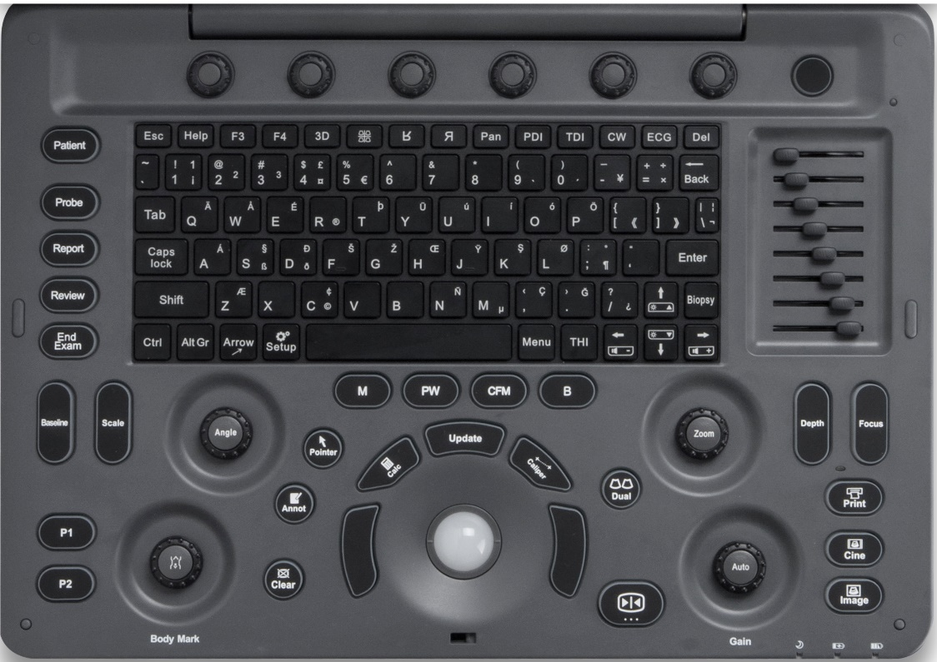
1
2
3
4
5
6
7
9
10
111
3
122
13
8

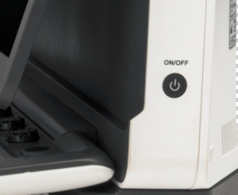
14

- Exam Procedure
Patient / Probe / Report / Review / End Exam
2. Standard Keyboard and Function Keys
3. Parameter Adjustment
Baseline / Scale / Angle / Zoom / Depth / Focus
4. User Defined Keys
P1/ P2
5. Annotation
Body mark / Pointer / Annotation / Clear
- Control Center Trackball / Update / Left & Right Set Buttons / Caliper / Calculation
- Imaging Mode
B / PW / M
- Image Management
Print / Cine / Image
- Freeze/ Unfreeze
- Automatic Parameter Optimization and Gain Adjustment
- Dual Mode
- TGC
- Parameter Knobs
- Power On

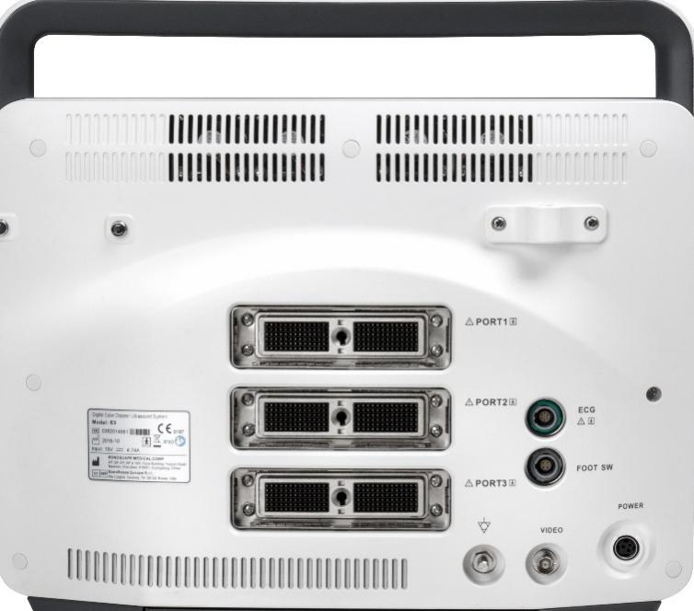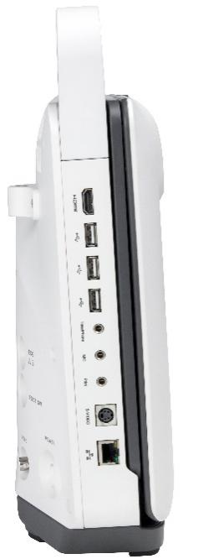
Grounded Cable
Print
MIC
Ethernet
S-Video
HeadPhone
USB
HDMI
Video
Power
Foot Switch
ECG
Probe Ports

1. Getting Start

Create new patient and get into the Scanning Mode
1. Press [Patient], to create a new patient with basic patient and exam information;
2. A patient ID is necessary and will be assigned if left empty;
3. Press [Probe] and move the [Trackball] to choose a probe and an appropriate exam.

2. Scanning

B Mode
- The default scanning mode is B mode; if you want to return to B mode while you are operating other modes, please press the [B] on keyboard;
2. Easily adjust parameters with the six knobs just under the monitor, press the right button for the next page of parameters.
3. Press [Auto] for one key image optimization.
2B/4B Imaging
1. Press [Dual] or [Quad] to get into 2B/4B imaging;
2. Press [Dual] or [Quad] to change the activated image.
3. Easily adjust parameters with the six knobs just under the monitor, press the right button for the next page of parameters.
Color/DPDI Mode
1. Press [CFM] to enter Color mode;
2. Move the [Trackball] and Press [Set] to change the position and size of the ROI;
3. Easily adjust parameters with the keys on the control panel: Baseline, Scale, Depth;
4. Easily adjust parameters with the six knobs just under the monitor, press the right button for the next page of parameters.
PW/CW Mode
1. Press [PW] to enter PW mode;
2. Move the [Trackball] to change the position of the sample volume;
3. Press [Set] and then move the [Trackball] to change the size of the sample volume, and rotate [Angle] to change the angle of the sample volume line;
4. Press [Update] to activate the Pulse Wave Doppler image;
5. CW is only available for phased array probes, press [CW] on the keyboard to enter CW mode.
6. Easily adjust parameters with the six knobs just under the monitor, press the right button for the next page of parameters.
Image Adjustments
Parameters in B Mode: Depth, Focus, Gain, Frequency, Line Density, Gray Map, Chroma, μ-Scan, Persist, DR, Power, Focus Area, Sector Width, Compound, Rotation, TSI;
Parameters in Color Mode: Gain, Baseline, Scale, Depth, Frequency, Line Density, Color Map, Rotation, B Reject, Persist, WF, Invert, Power.

3. Measurements, Annotations and Body Marks
Measurements, annotations and body marks are active both in scanning mode and in frozen mode;
Measurements
1. Press [Caliper] to calculate the distance, area, volume and angle;
2. Press [Calc] to enter the application measurements menu;
3. Choose the desired measurement item by moving the [trackball], use [Set] to choose and mark the correct position.
4. Press [Clear] to clear all marks on the image.
Annotations
- Annotations dictionary
- Press [Annot] to activate the annotations dictionary, select from the annotations dictionary.
- Move the [Trackball] to change the position of the annotation.
- Press [Set] to place the annotation at the desired position.
- Input annotations
- Press [Annot] to activate the annotations function and move the [Trackball] to change the position of the annotation.
- Input the annotation through the keyboard.
- Press [Set] to confirm the annotation and position.
Body Marks
1. Press [Body Mark] and choose the desired body mark.
2. Move the [Trackball] to place the probe marker, and rotate [Body Mark] to adjust the orientation of the probe marker.
3. Press [Set] to place body mark at the desired position.

- Post Scanning

Save Images and Cine
Press [Image] to save a single frame image, or press [Cine] to save a cine on the system.
Review Patient File
Press [Review] to review the patient file that is currently active, then select a certain exam to review images and cines.
Report and Print
1. Press [Report] to enter the report interface for reviewing all measurement results and edit graphs.
2. Click [Image View] to add images, Click [Summary] to input a summary for the exam;
3. Click [Prev.Save] to preview the report and then click [Print] to print the report.
End Exam Press [End Exam] to end the examination.
Start a New Patient by repeating the instructions above

5. Image Management

- Press [Patient] in the control panel, then enter the [Patient List] to open an exam of the desired patient; or press [Review] and choose the desired patient.
2. Choose the type of medium, then choose the type of file you want to export, like JPG/BMP/TIF/AVI/WMV/PDF/TXT/HTML;
3. Click [Export] to send the images to the selected USB.
4. Click [DICOM Send] to upload files to DICOM service.

6. User-defined Presets

- After you change some parameters to optimize the scanning image, press “S” on the alphabet keyboard to enter the User Preset Menu;
2. Name the new exam, and choose the Exam Type and Part accordingly; then click [Save];
3. You can also enter [Setup] - [Exam Preset] to change the order of all exam modes.

