E1 Quick Manual
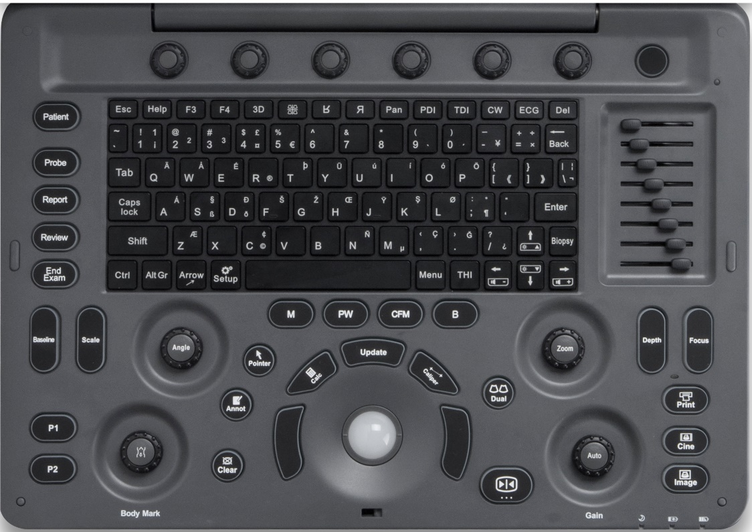
1
2
3
4
5
6
7
9
10
111
3
122
13
8

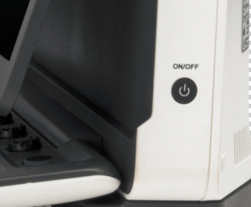
14

- Exam Procedure
Patient / Probe / Report / Review / End Exam
2. Standard Keyboard and Function Keys
3. Parameter Adjustment
Baseline / Scale / Angle / Zoom / Depth / Focus
4. User Defined Keys
P1/ P2
5. Annotation
Body mark / Pointer / Annotation / Clear
- Control Center Trackball / Update / Left & Right Set Buttons / Caliper / Calculation
- Imaging Mode
B / PW / M
- Image Management
Print / Cine / Image
- Freeze/ Unfreeze
- Automatic Parameter Optimization and Gain Adjustment
- Dual Mode
- TGC
- Parameter Knobs
- Power On

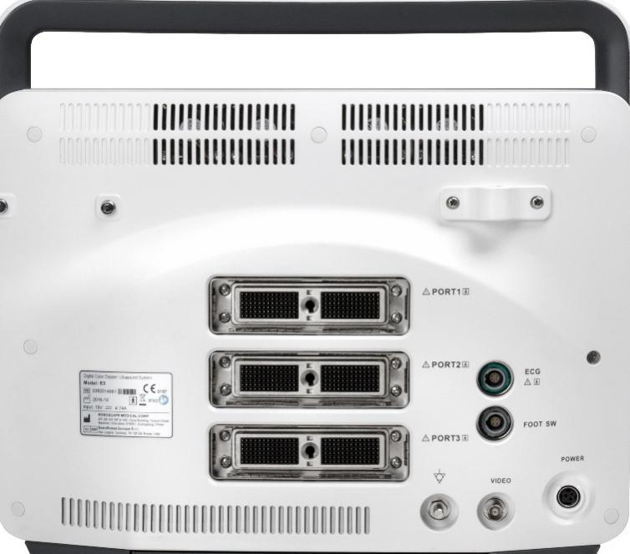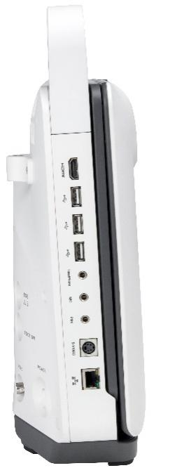
Grounded Cable
Print
MIC
Ethernet
S-Video
HeadPhone
USB
HDMI
Video
Power
Foot Switch
ECG
Probe Ports

1. Getting Start

Create new patient and get into the Scanning Mode
1. Press [Patient], to create a new patient with basic patient and exam information;
2. A patient ID is necessary and will be assigned if left empty;
3. Press [Probe] and move the [Trackball] to choose a probe and an appropriate exam.

2. Scanning

B Mode
- The default scanning mode is B mode; if you want to return to B mode while you are operating other modes, please press the [B] on keyboard;
2. Easily adjust parameters with the six knobs just under the monitor, press the right button for the next page of parameters.
3. Press [Auto] for one key image optimization.
2B/4B Imaging
1. Press [Dual] or [Quad] to get into 2B/4B imaging;
2. Press [Dual] or [Quad] to change the activated image.
3. Easily adjust parameters with the six knobs just under the monitor, press the right button for the next page of parameters.
PW Mode
1. Press [PW] to enter PW mode;
2. Move the [Trackball] to change the position of the sample volume;
3. Press [Set] and then move the [Trackball] to change the size of the sample volume, and rotate [Angle] to change the angle of the sample volume line;
4. Press [Update] to activate the Pulse Wave Doppler image;
5. Easily adjust parameters with the six knobs just under the monitor, press the right button for the next page of parameters.
Image Adjustments
Parameters in B Mode: Depth, Focus, Gain, Frequency, Line Density, Gray Map, Chroma, μ-Scan, Persist, DR, Power, Focus Area, Sector Width, Compound, Rotation, TSI;
Parameters in Color Mode: Gain, Baseline, Scale, Depth, Frequency, Line Density, Rotation, Persist, WF, Invert, Power.

3. Measurements, Annotations and Body Marks
Measurements, annotations and body marks are active both in scanning mode and in frozen mode;
Measurements
1. Press [Caliper] to calculate the distance, area, volume and angle;
2. Press [Calc] to enter the application measurements menu;
3. Choose the desired measurement item by moving the [trackball], use [Set] to choose and mark the correct position.
4. Press [Clear] to clear all marks on the image.
Annotations
- Annotations dictionary
- Press [Annot] to activate the annotations dictionary, select from the annotations dictionary.
- Move the [Trackball] to change the position of the annotation.
- Press [Set] to place the annotation at the desired position.
- Input annotations
- Press [Annot] to activate the annotations function and move the [Trackball] to change the position of the annotation.
- Input the annotation through the keyboard.
- Press [Set] to confirm the annotation and position.
Body Marks
1. Press [Body Mark] and choose the desired body mark.
2. Move the [Trackball] to place the probe marker, and rotate [Body Mark] to adjust the orientation of the probe marker.
3. Press [Set] to place body mark at the desired position.

- Post Scanning

Save Images and Cine
Press [Image] to save a single frame image, or press [Cine] to save a cine on the system.
Review Patient File
Press [Review] to review the patient file that is currently active, then select a certain exam to review images and cines.
Report and Print
1. Press [Report] to enter the report interface for reviewing all measurement results and edit graphs.
2. Click [Image View] to add images, Click [Summary] to input a summary for the exam;
3. Click [Prev.Save] to preview the report and then click [Print] to print the report.
End Exam Press [End Exam] to end the examination.
Start a New Patient by repeating the instructions above

5. Image Management

- Press [Patient] in the control panel, then enter the [Patient List] to open an exam of the desired patient; or press [Review] and choose the desired patient.
2. Choose the type of medium, then choose the type of file you want to export, like JPG/BMP/TIF/AVI/WMV/PDF/TXT/HTML;
3. Click [Export] to send the images to the selected USB.
4. Click [DICOM Send] to upload files to DICOM service.
6. User-defined Presets

- After you change some parameters to optimize the scanning image, press “S” on the alphabet keyboard to enter the User Preset Menu;
2. Name the new exam, and choose the Exam Type and Part accordingly; then click [Save];
3. You can also enter [Setup] - [Exam Preset] to change the order of all exam modes.

