CHISON SonoBook 9
Quick Reference Guide

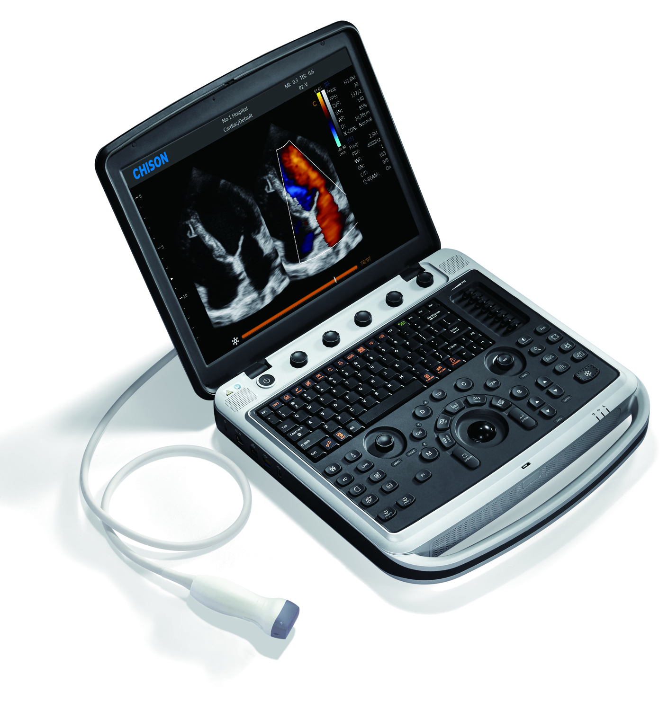

1
ec
dc
c
e
d
c
b
a
3
4
5
2
28
31
30
10
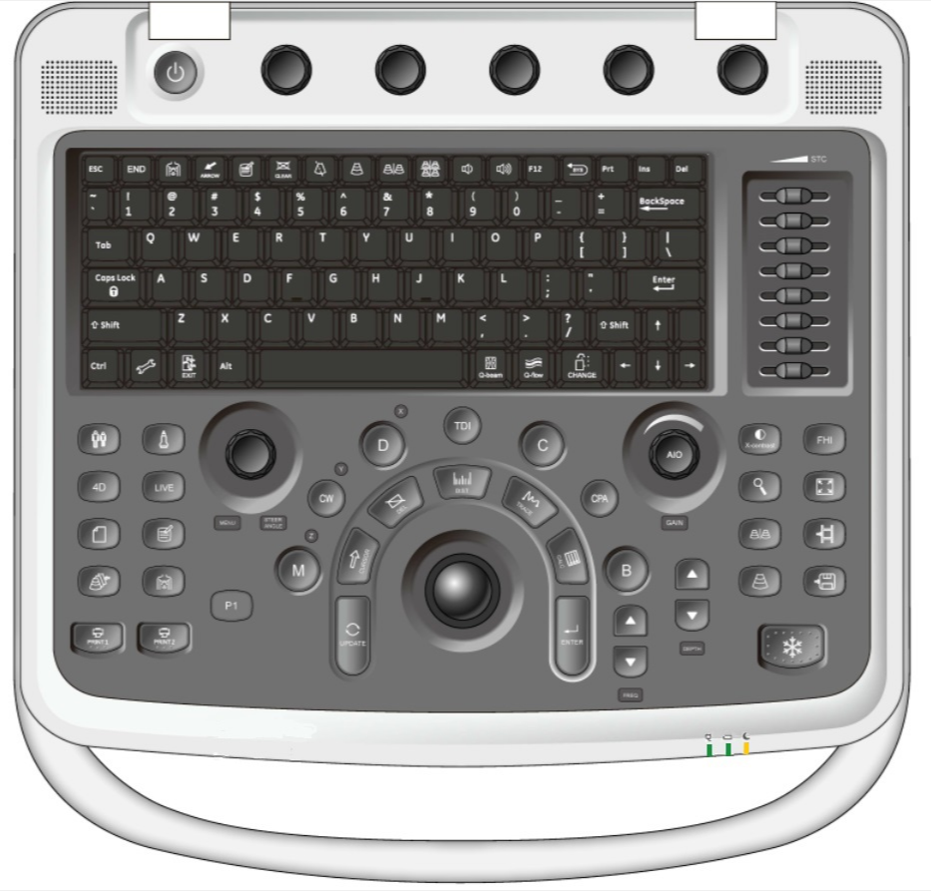
b
24
a
c
b
a
b
a
fc
gc
b
a
111
6
7
8
23
22
21
27
26
25
29
18
15
14
132
1200
9
17
20
19
16

- Parameter adjustment area(Key1-a, Key1-b, Key1-c, Key1-d, Key1-e):
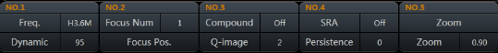
1-1: Press each key to adjust the first-line parameters, such as Frequency, Focus number, Compound, SRA, Zoom;
1-2: Rotate each key to adjust the second-line parameters, such as Dynamic, Focus position, Q-image, Persistence, Zoom ratio;
- Power Button: press the power button to turn on/off the system;
- Alphanumeric Keyboard
- Probe Selection
- Patient Information
- 4D Function (4D sample box and active LIVE mode )
- Report
- Archive(review the previous files)
- Print
- Menu(subordinate adjustment parameters) /Angle
- Comment
- Body Mark
- P1(user-defined key)
- Function Select (B,C,D,M mode, TDI , CW, CPA mode)
- Update
- Cursor
- Delete
- Trackball
- Measurement and calculation package
- Enter
- Frequency
- Depth
- Freeze
- Single image and Dual images
- Save image & cine
- Full Screen
- FHI (Fusion Harmonic Imaging)
- X – Contrast (adjust the contrast resolution to 3 levels )
- Zoom
- AIO(auto image optimization)/Gain
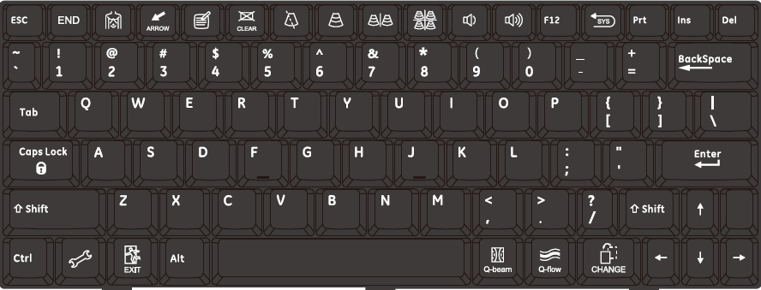
- STC
42
45
44
46
48
47
39
43
40
41
38
37
36
35
34
33
32
- End Exam
- Body Mark
- Arrow
- Comment
- Clear(clear all the arrow, comment, body mark)
- Biopsy(guide line for biopsy)
- Single image
- Dual images
- Four images
- Audio down
- Audio up
- System recover(back to factory mode)
- System Setting
- Exit
- Q-Beam(multi-beam former)
- Q-Flow(enhance the sensitivity of low-velocity flow)
- Change(change the measurement package )

Quick Reference Guide
Getting Started
Establish New Patient
1. Press [Patient] (Key5), fill in the basic patient information via alphanumeric keyboard
2. Press [Probe] (Key4), select probe and exam mode
Scanning
B Mode
1. Adjust the interested parameters such as gain (Key30), STC (Key31), frequency (Key1-a), dynamic (Key1-a) etc.
2. Rotate the [B] (Key14-a) knob to adjust the gain, adjust frequency and dynamic range through parameters adjustment area.
CFM Mode
1. Press [C] (Key14-c) to enter Color mode.
2. Move [Trackball] (Key18) to change the position of ROI.
3. Press [ENTER] (Key20), and then move [Trackball] (Key18) to change the size of ROI, press [ENTER] (Key20).
PW/CW Mode
1. Press [D] (Key14-e)/ [CW] (Key14-f) to enter PW/CW mode.
2. Move [Trackball] (Key18) to change the position of ROI.
3. Change the size and angle of sample volume via trackball and angle key.
Press [Update] (Key15) to get the Pulse Wave Doppler.
Image Adjustment
1. Mode displaying areas (Key14): Click to display the active imaging mode.
2. Parameter adjusting areas (Key1): Display the parameters in the current imaging mode.
3. Knob adjusting areas (Key1): Display the knob controlled parameters that can be adjusted by the knobs, from Key1-a~ Key1-e.
The parameters in B mode: i-image, Dynamic Range, AIO, Compound, SRA, Quad Mode, THI, Focus Number, Frequency, Focus Position, Chroma, Trapezoid, Smooth. 2D Steer, Acoustic Power.
The parameters in Color mode: WF, Sample Size, Persistence, B/BC mode, Priority, Line Density, Dual Live, Flow State, Invert, Frequency, Scale, Baseline, Map, Steer, Color IP, Acoustic Power, Smooth, Focus Position (the parameters might be displayed
on different pages).
Other excellent modes(optional)
4D Mode
1. Press [Probe] (Key4), select the volume probe.
2. Click [4D] (Key6-a) to enter and adjust the ROI and curve VOI.
3. Click [LIVE] (Key6-b) to enter the 4D image real-time status.
TDI mode
1. Press [TDI] (Key14-d) to enter TDI mode.
2. Move [Trackball] (Key18) to change the position of ROI.
3. Press [D] (Key14-e) to enter TDI+PW mode; Press [M] (Key14-g) to enter TDI+M mode
Color M Mode
1. Press [C] (Key14-c) to enter Color mode.
2. Press [M] (Key14-f) to enter Color M mode.
3. Move [Trackball] (Key18) to change the position of ROI.
4. Press [Update] (Key15) to get the spectrum
Free M Mode
1. Press [M] (Key14-f) to enter Color M mode.
2. Press [Update] (Key15) to get the spectrum
3. Press [Menu] (Key10), and press it again to enter [Free M Mode], then rotate [Menu] (Key10) to choose 1,2 or 3 sample lines
Realtime Panoramic Imaging
- Press [Menu] (Key10), and rotate it to choose [Realtime Panoramic],
- Press [Menu] (Key10) again to enter this mode
Measurement
1. Press [Freeze] (Key23) to freeze the image before the measurement.
2. Press [Calc] (Key19-c) to enter the application measurement calculation packages.
3. Move the cursor to choose the measurement tool, and then choose the right measurement
Post Scanning
Comment and Body Mark
Comment
1. Press [Comment] (Key11) to change the comment setting position and add the comment to the image.
Body Mark
1. Press [Body Mark] (Key12) and choose the desired body mark.
2. Move [Trackball] (Key18) to place the probe marker and rotate the [angle] to adjust the orientation
Save Images or Cines
1. Press [Save image] (Key25-a) or [Save cine] (Key25-b) to save a single-frame image or a movie in real time.
Report and Print
1. Press [Report] (Key7), move the cursor to the comment text box and type the text.
2. Click Image to add images, and then click [Preview] to
preview in A4 paper, click [Print] to print directly.
End Exam
Press [End Exam] (Key32) to end one examination. You may start a new exam by repeating the instructions above.
Image Management
Image Transfer
1. Press [archive] (Key8) to enter image management and select the image to send to USB, back up to other systems or DICOM, etc.
2. Or, Press [Review] and select the image to send to USB, DICOM, etc.
Note: For detailed information, please refer to the instruction manual.

CHISON MEDICAL TECHNOLOGIES CO., LTD – All rights reserved.
Chison Medical Technologies Company reserves the right to make changes in specifications and features shown herein, or discontinue the product described at any time without notice or obligation.
For more information visit us at www.chison.com

